Aashritha kulkarni- 11556500. Navyath Reddy Billa- 11593755 Jayram Tatipally-11598288

DATA MODELING AND INFORMATION PROFESIONALS PROJECT-5707

2022

The **Dataset** we took is **FIFA World cup 2022**, the data is till December 10th, 2022. This Dataset consists of Teams name, match number, Score, team captain, Referee, matches won, audience attendance, total shots, total possessions, Venue.

The **Scope** of the project to know complete minor detail about FIFA World cup. With this dataset we can easily know the team names, games they played with, who won the match, where the game took place, how many people came to watch the match, who was the referee.

**User Requirements** That system will take care of all the smallest detail of the FIFA World Cup and be helpful for comparison in the future before or after games.

**Business Rules for Database:**

1. There is a particular sequence number for a particular match. Every match has its own unique number.

2. No two matches have the same number.

3. Every match has happened in one day of the week.

4. Each match has a particular record of the score.

5. Each team will happen in a specific venue, and it cannot happen in two different venues.

6. Every match has some attendance count, which is unique for a team, and it may be some arbitrary number.

7. Every team will have a home captain and away captain, who can be a player from its home country only.

8.There are many parameters which are used to measure the team performance and these values can be any positive numbers ranging from zero. (home position, away position, home attempted passes, away completed passes).

**Entity Relationship Diagram (ERD)** with Crow’s Foot Notation:

The Entity Relationship Diagram has the attributes, key values,

Appropriate entities.

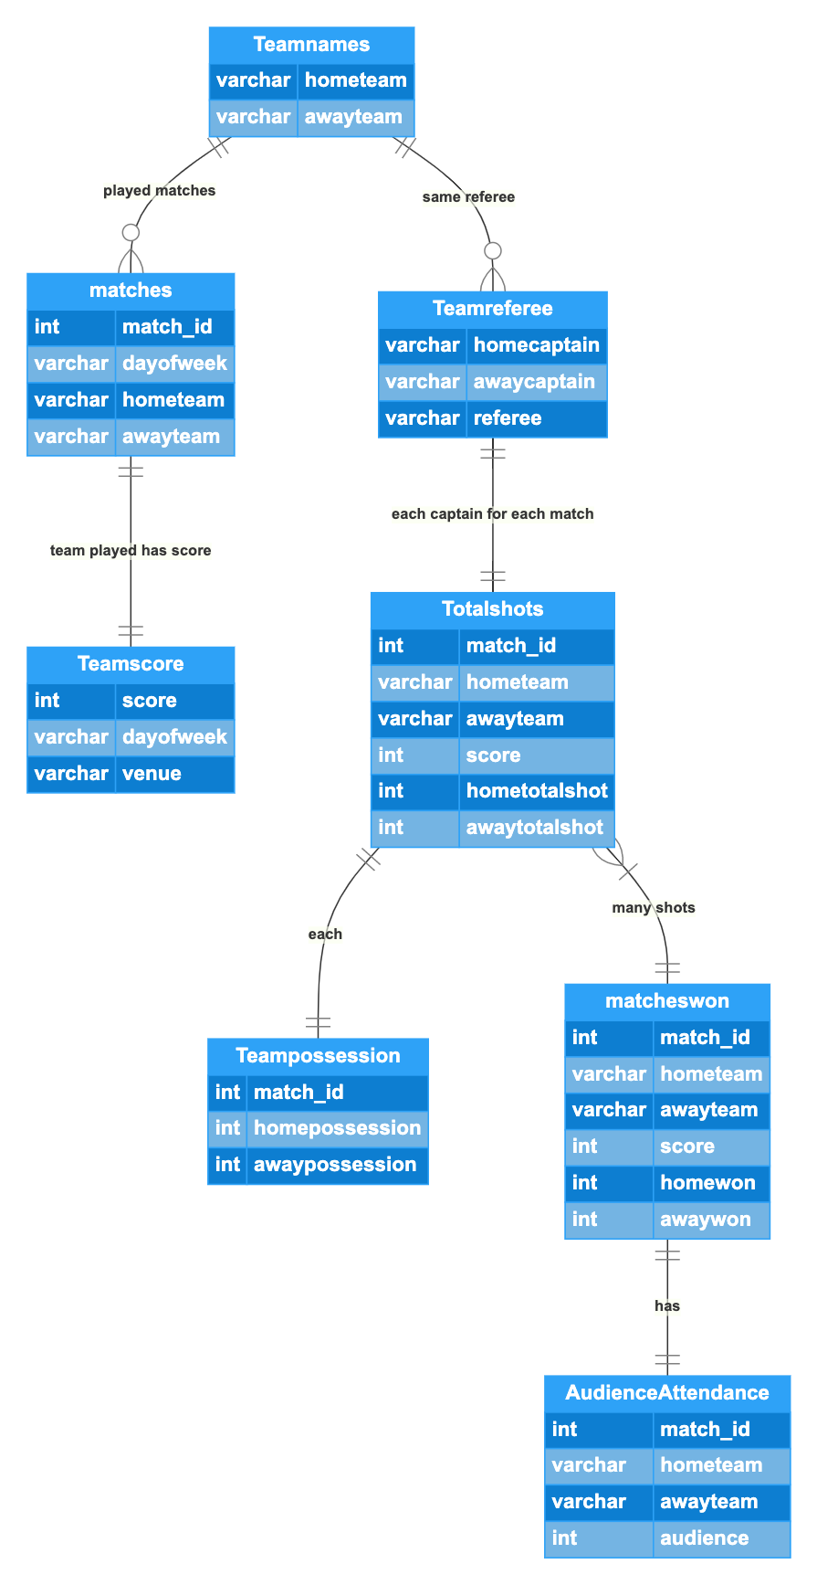

**Data Dictionary:**

The tables are Team names, Matches, Team Score, Team Referee, Total shots, Team possession, Matches won and Audience Attendance.

The columns in tables and attributes are match_id(int), dayofweek(varchar), home team(varchar), away team(varchar), home captain(varchar), away captain(varchar), referee(varchar), venue(varchar), score(int), home total shot(int), away total shot(int), home possession(int), away possession (int), home won(int), away won(int), audience (int).

**Database system in MYSQL**

**Data Entry and Update:**

Table1: Teams

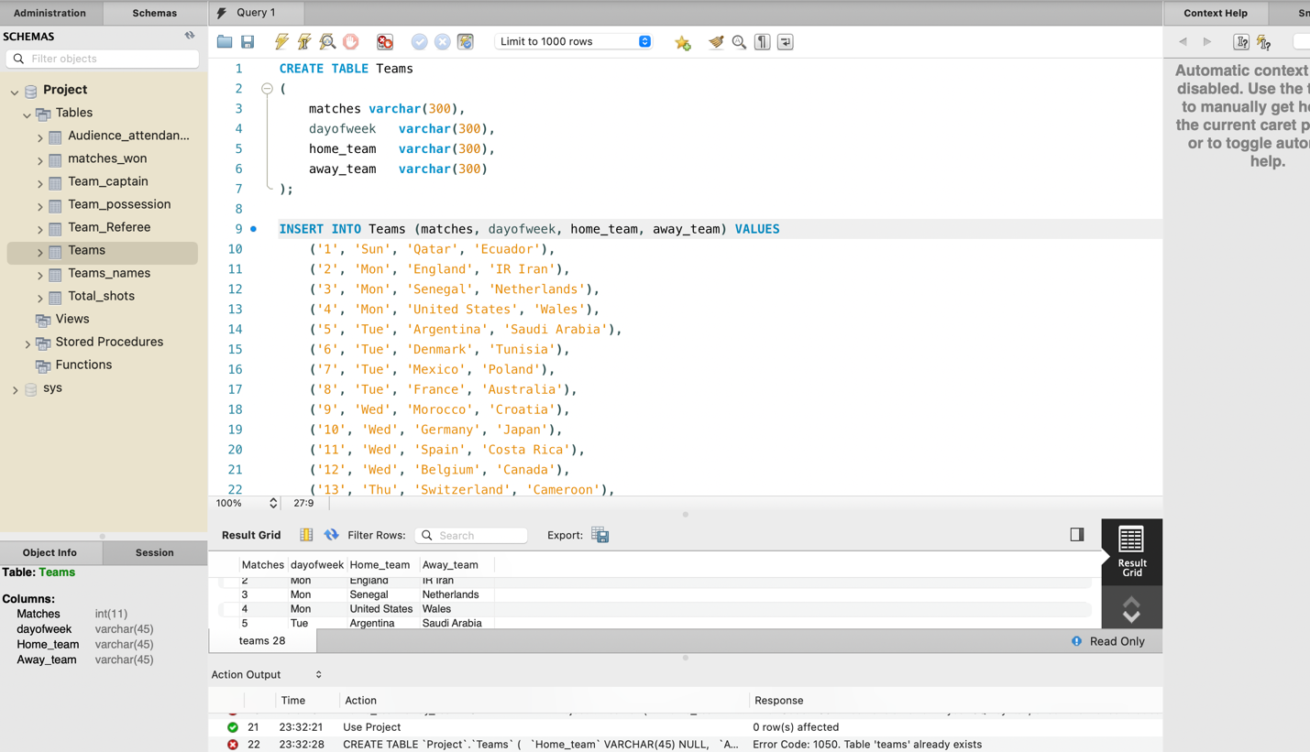

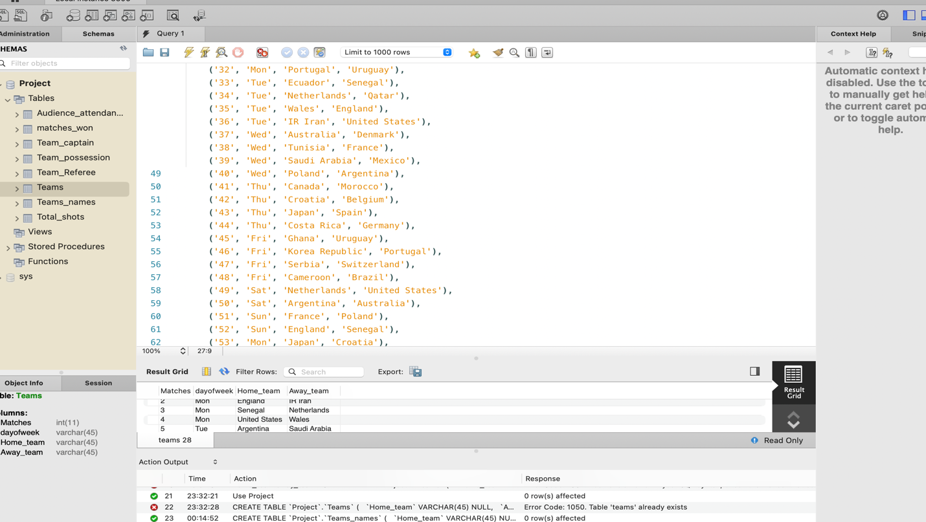

Table 2: Teams name

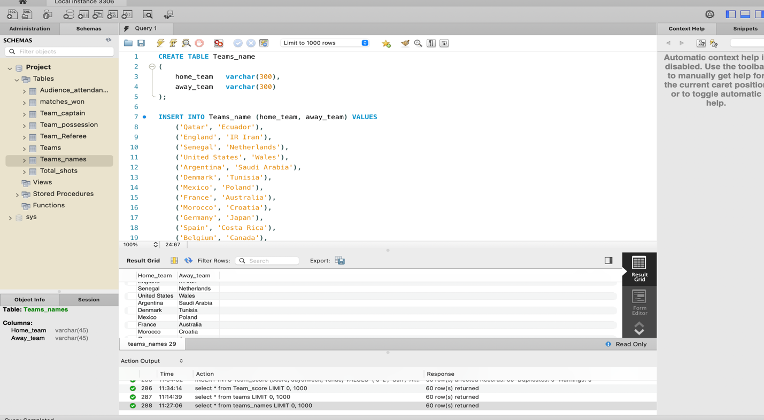

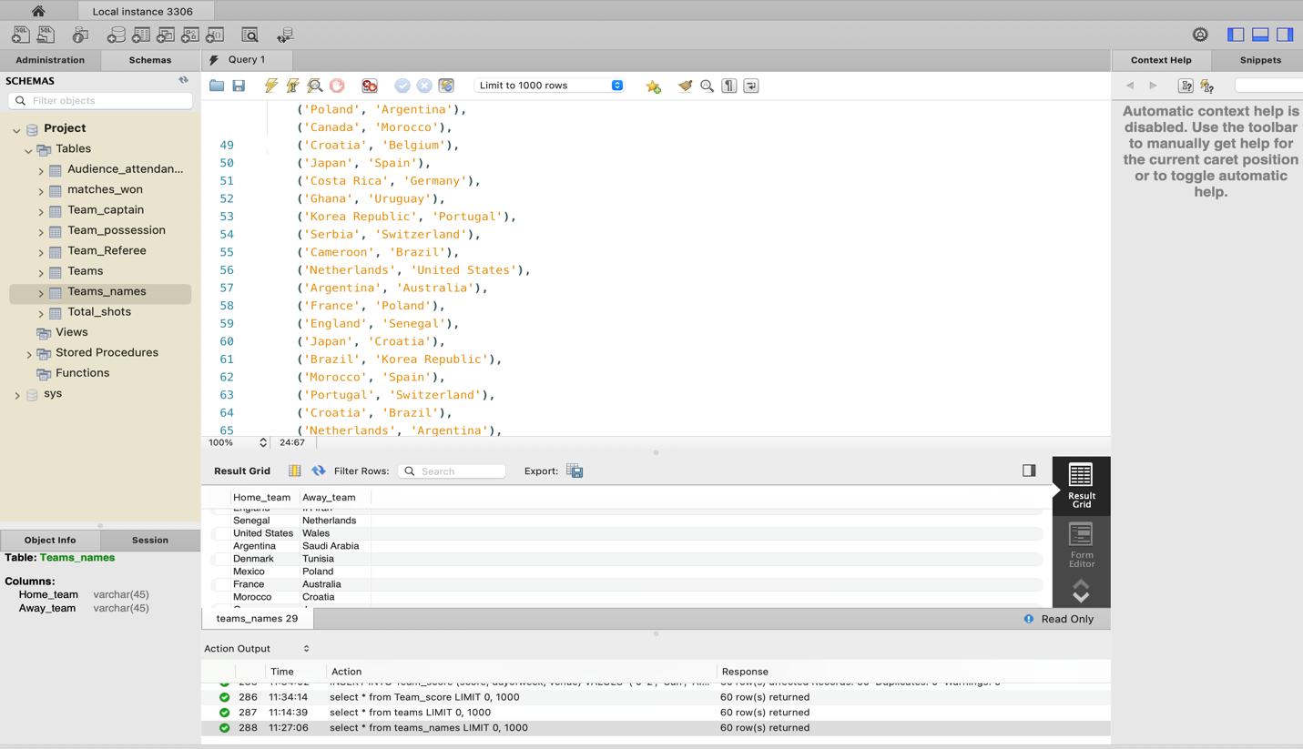

Table 3: Team_score

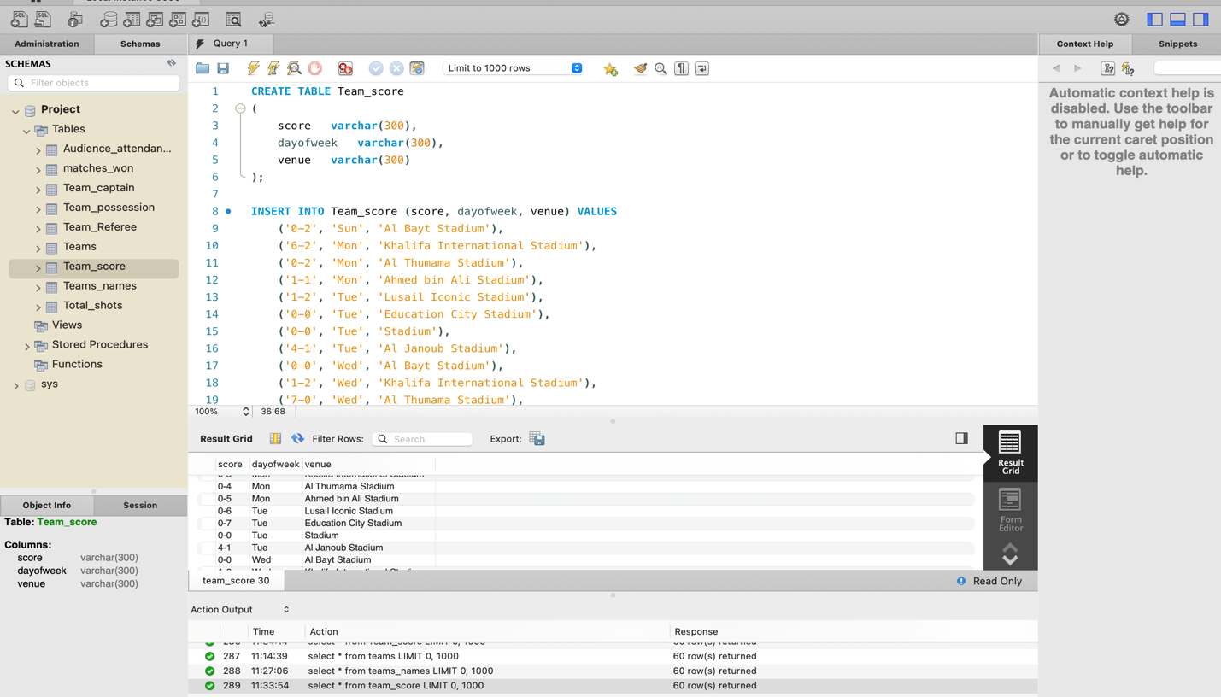

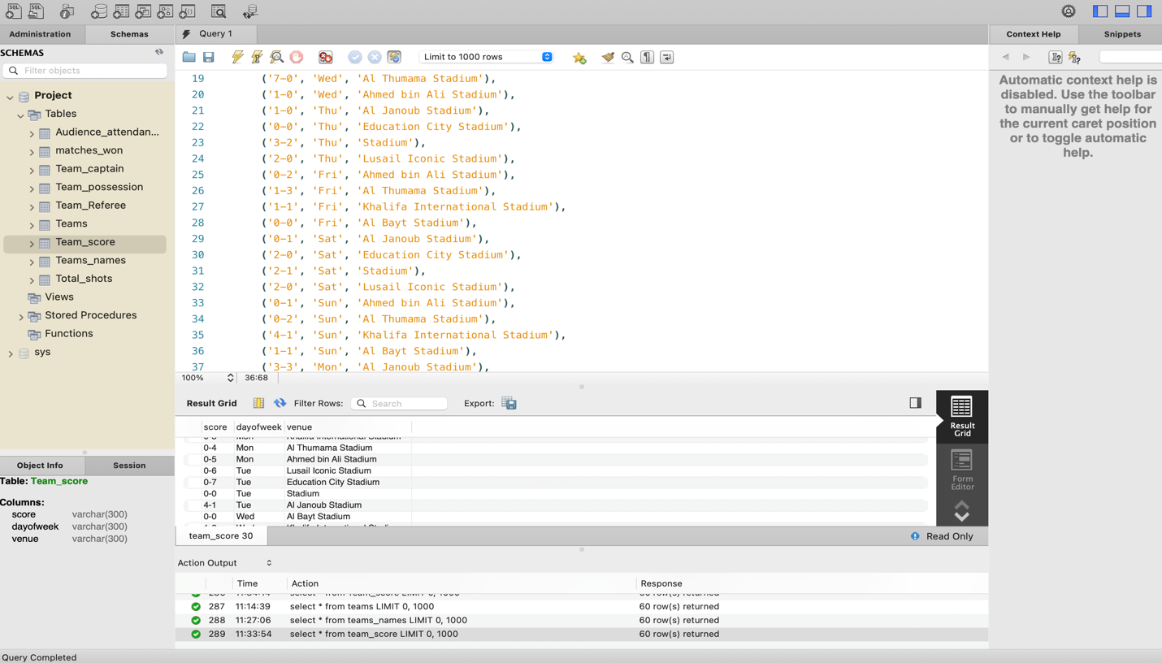

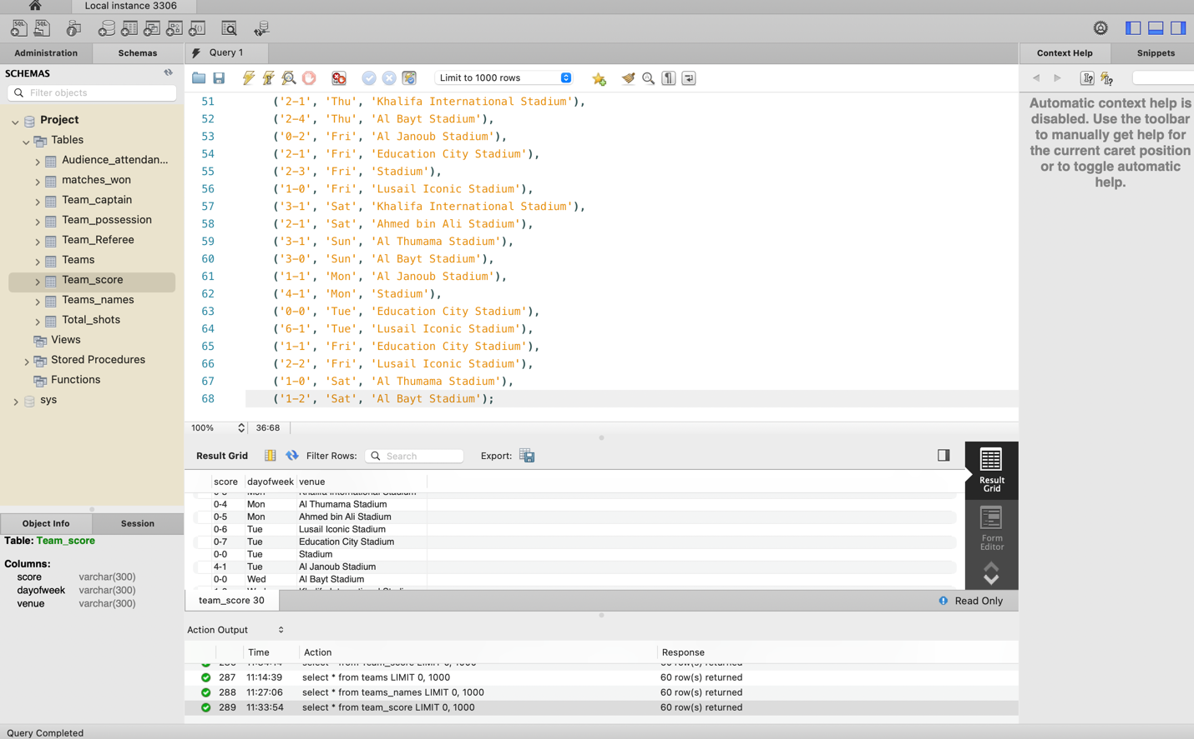

Table 4: Team_referee

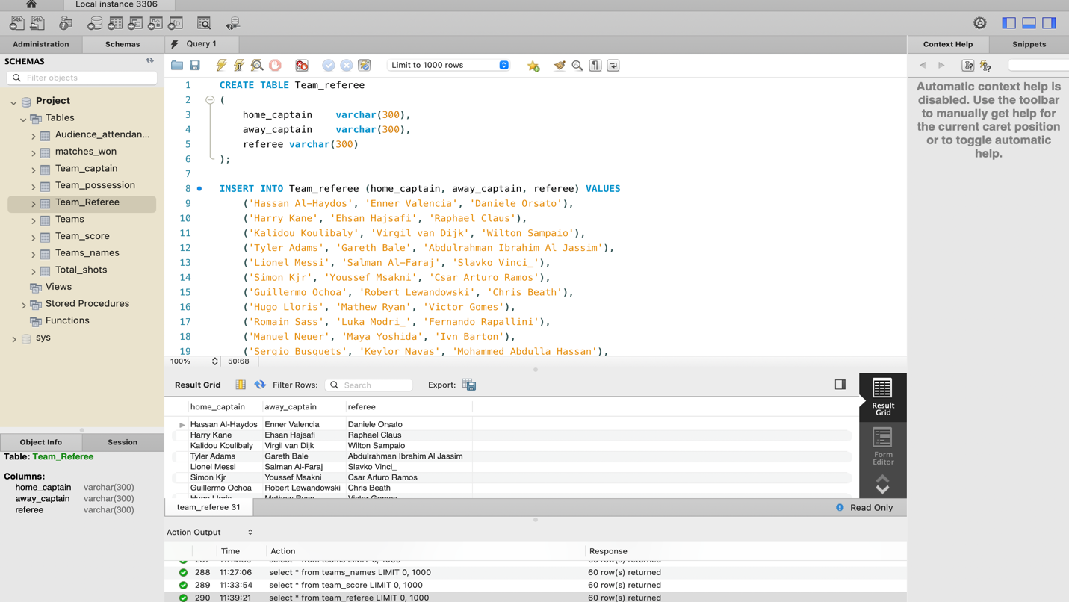

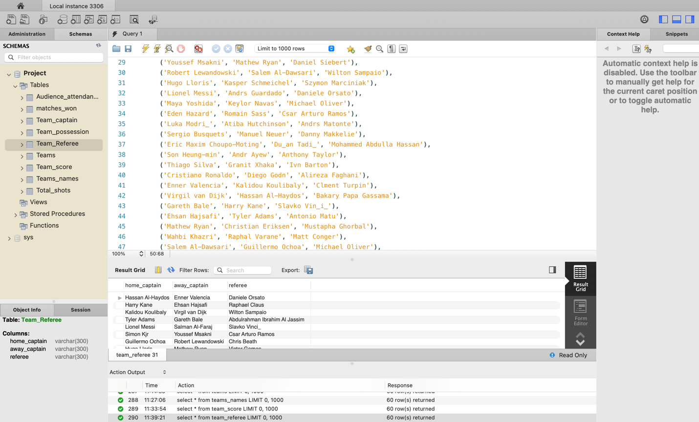

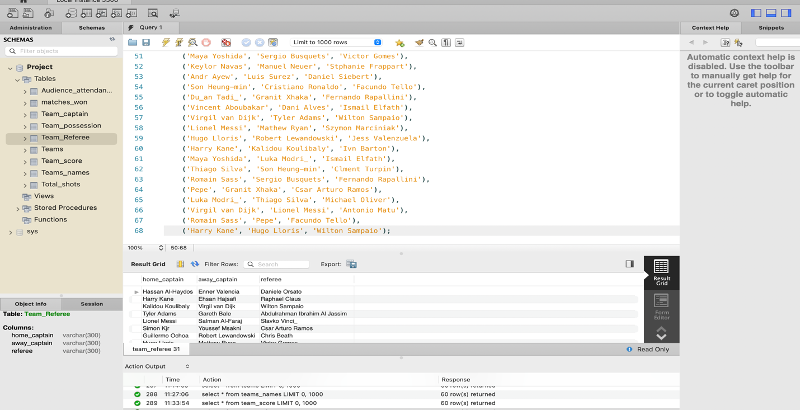

Table 5: Total_shots

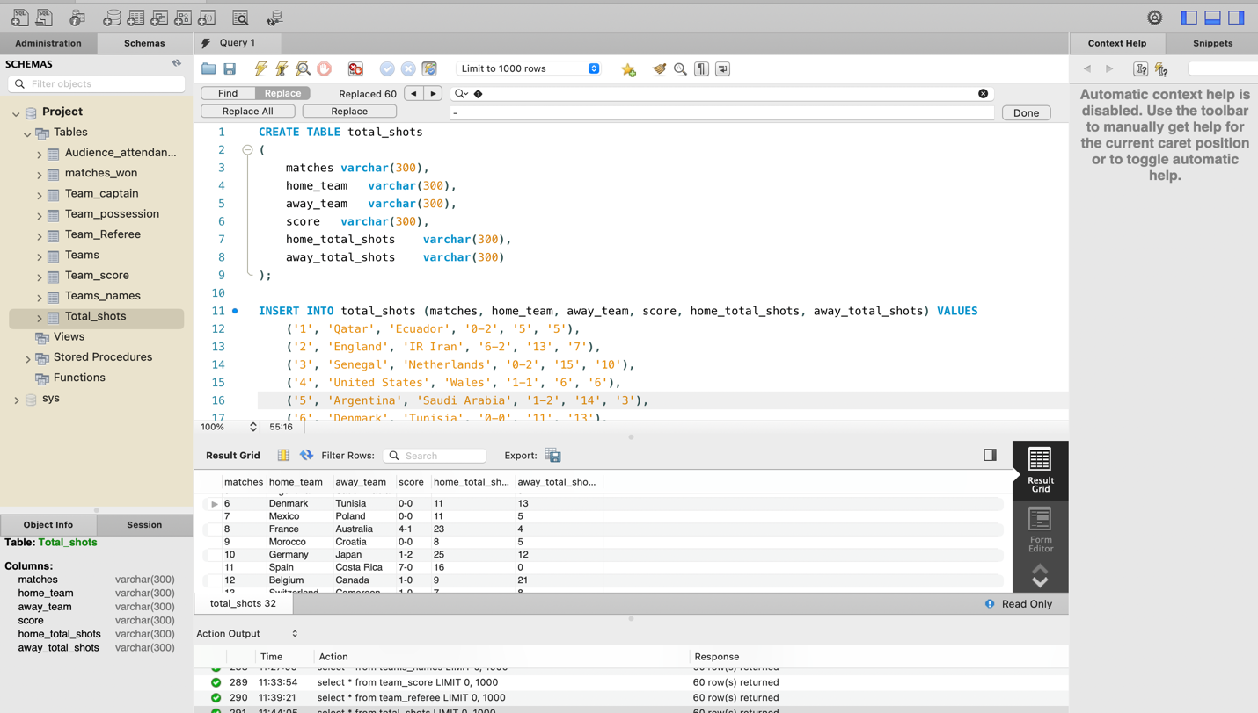

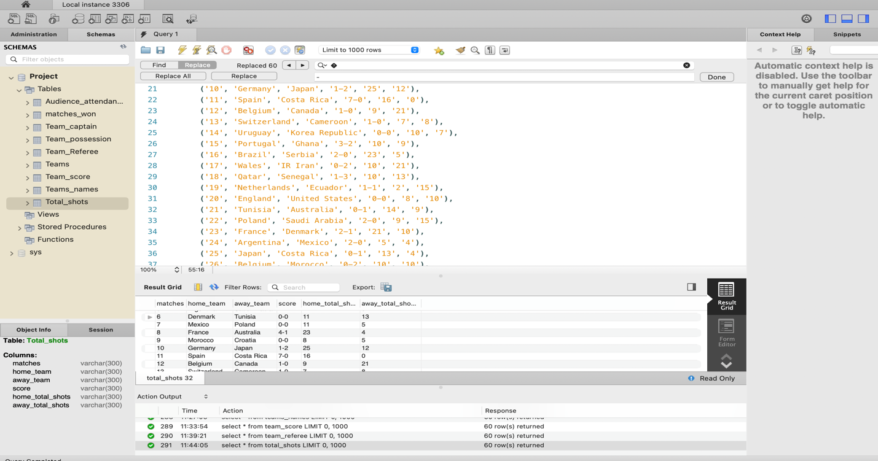

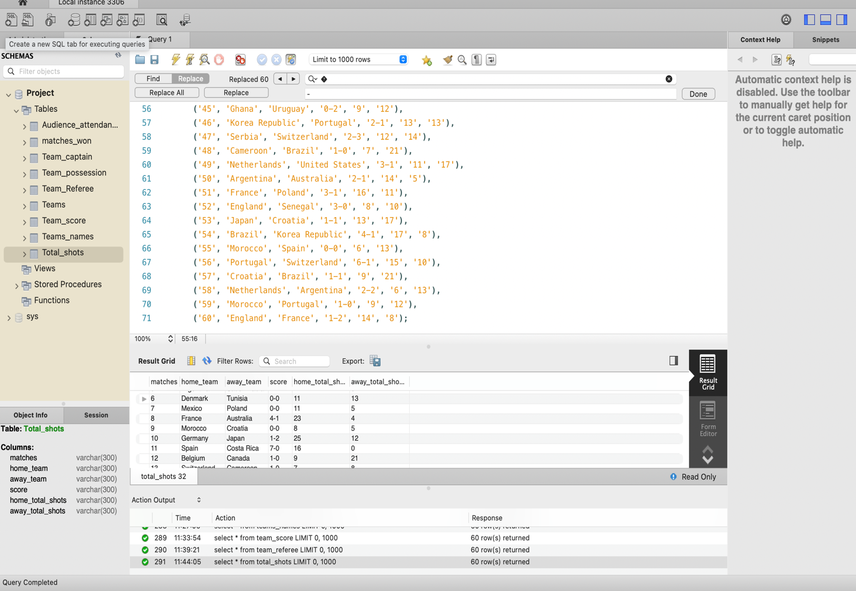

Team 6: Team_possession

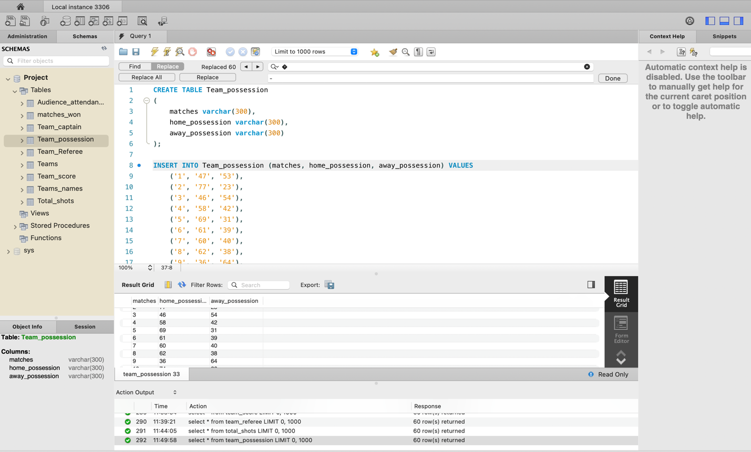

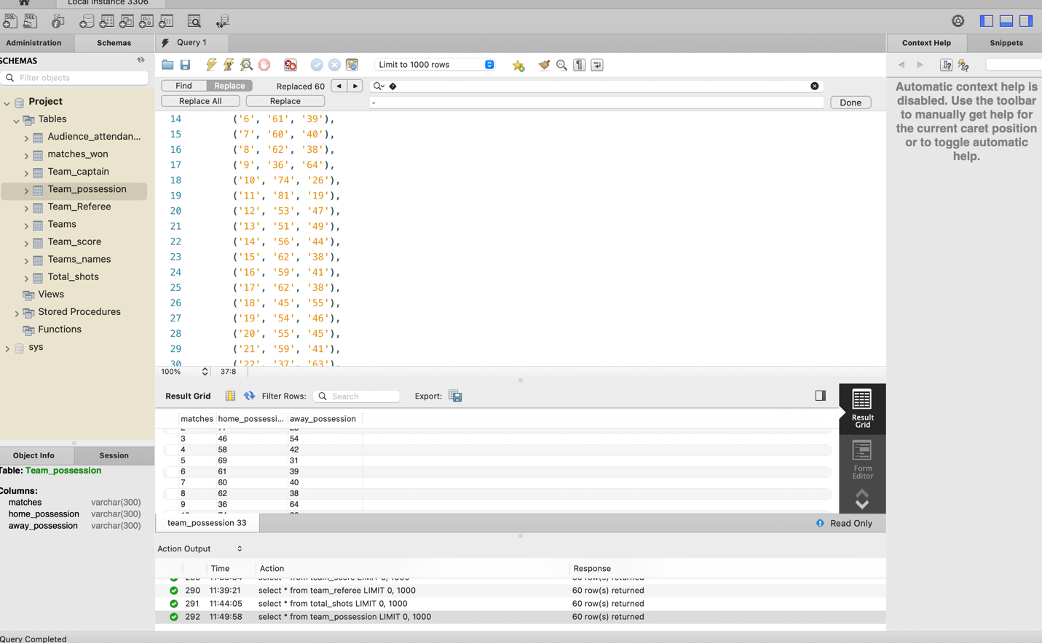

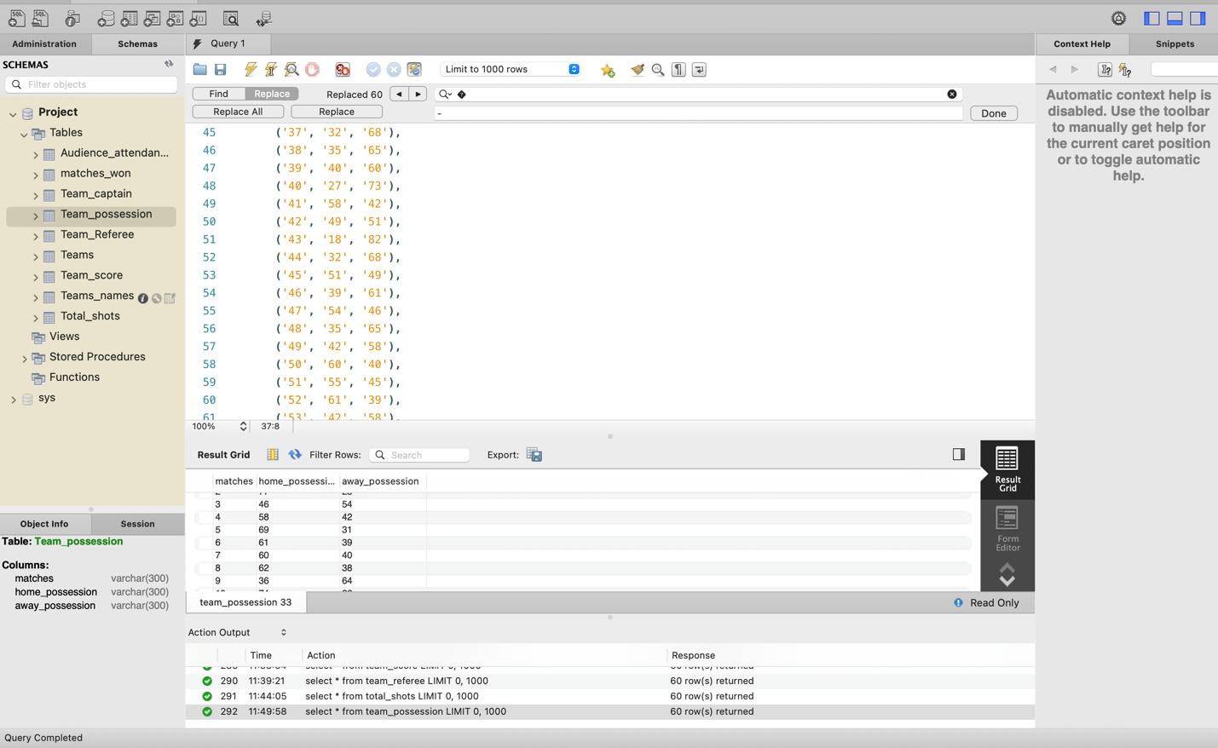

Team 7: Matches_won

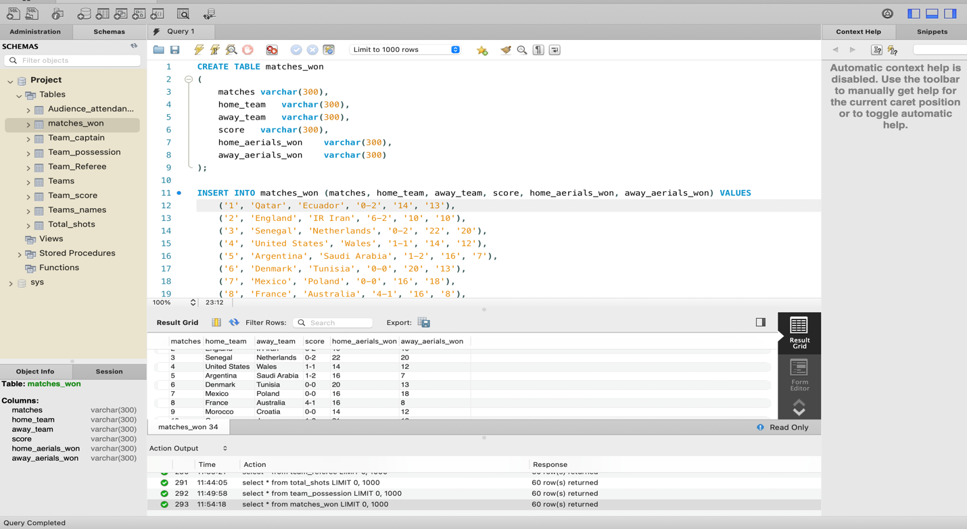

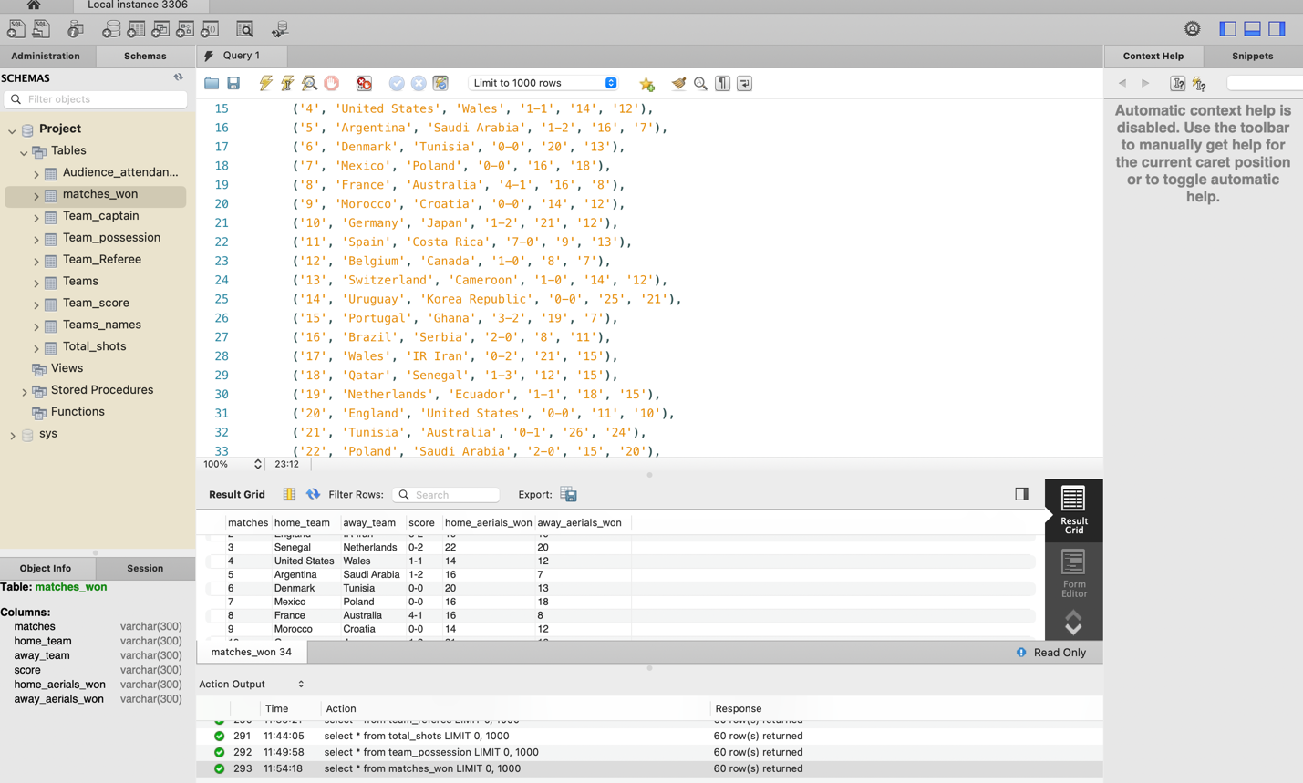

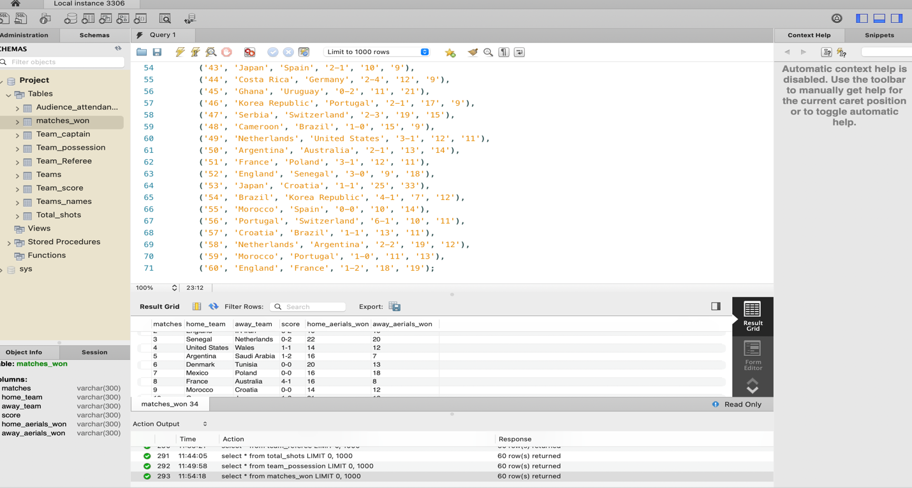

Table 8: Audience Attendance

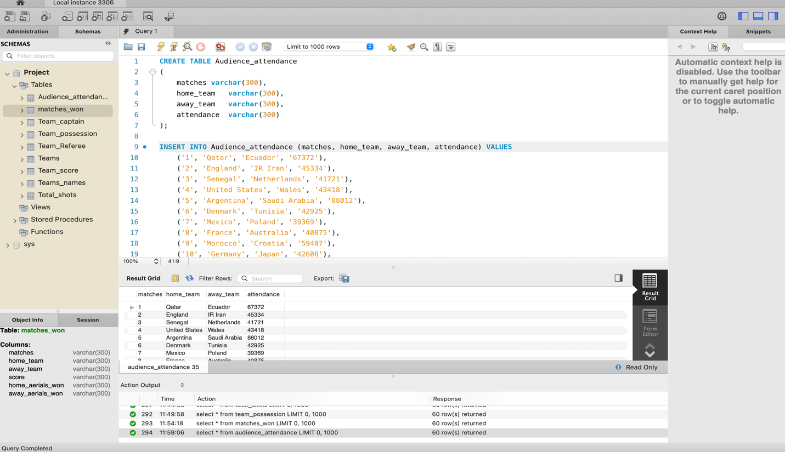

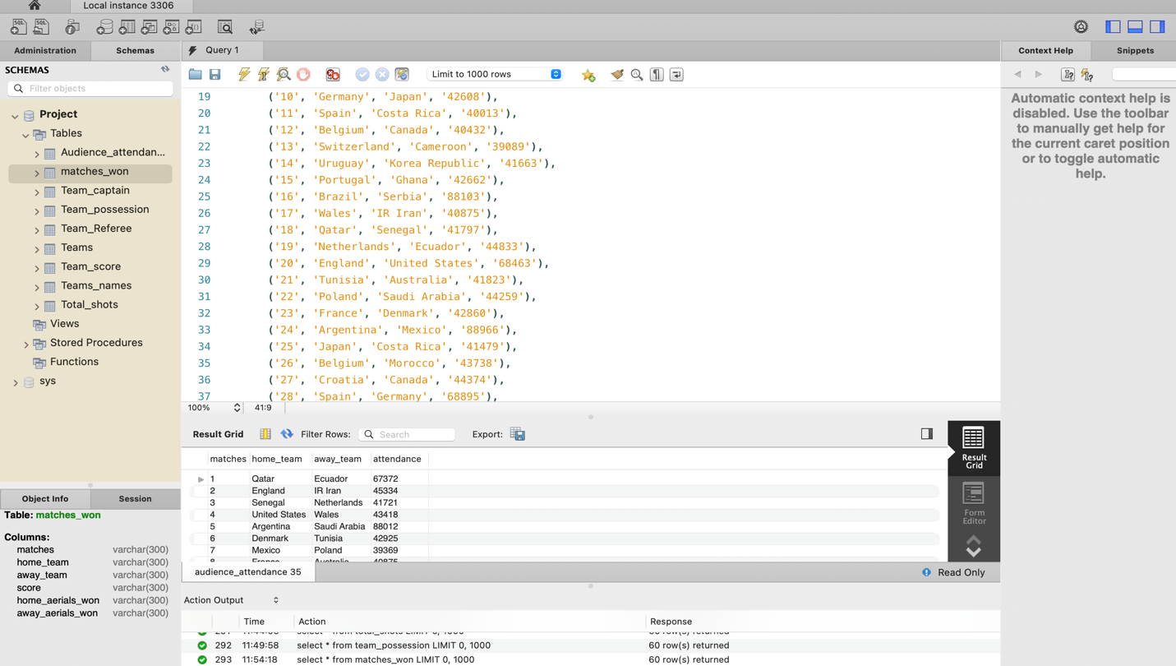

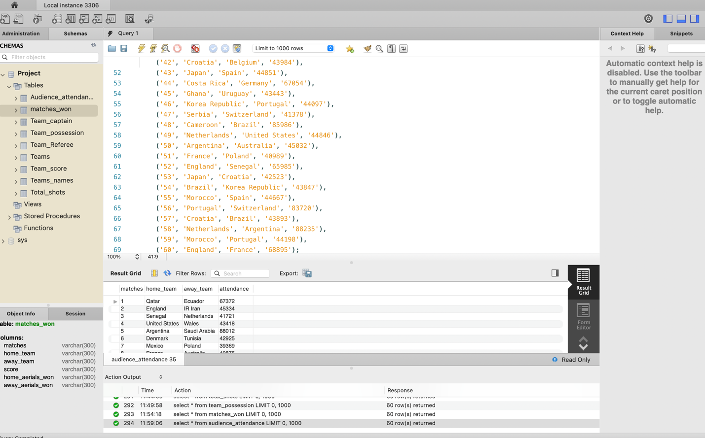

**Data Retrieval and Simple Reports**

1. To know the team names, the day they played and the order of the match they played.

select * from teams order by matches;

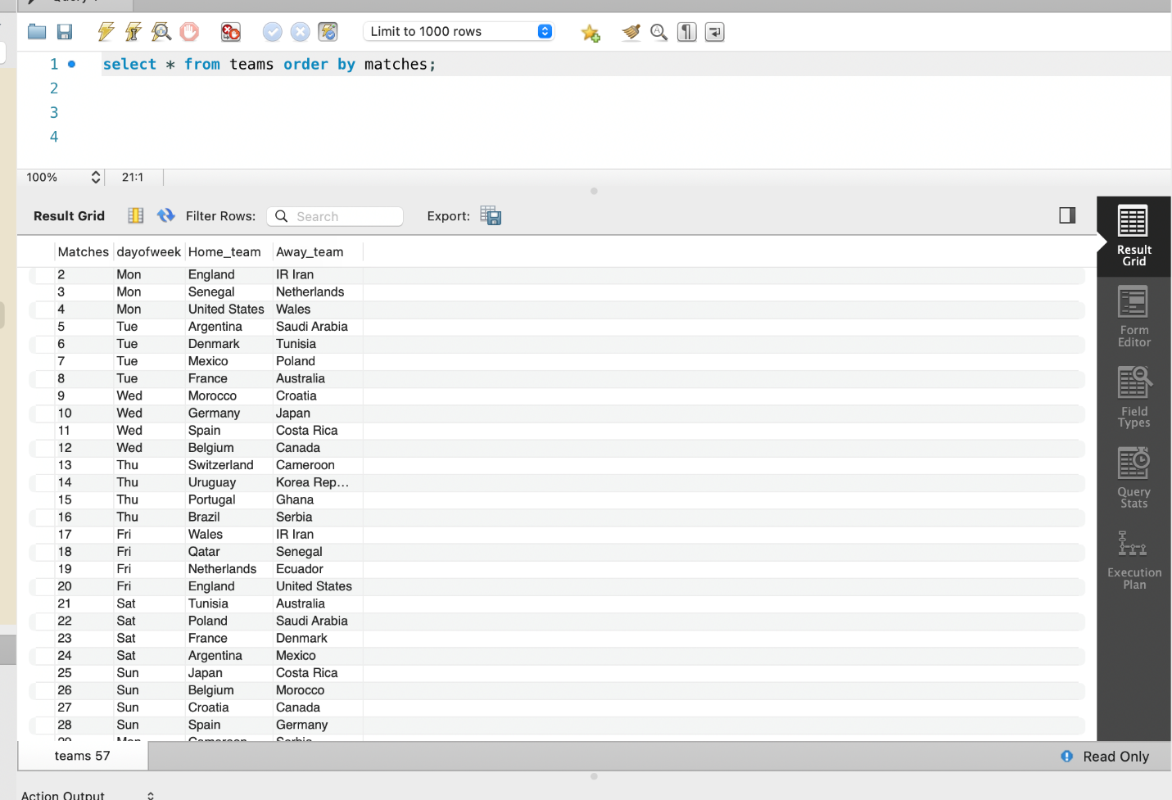

1. To know the match who played, and the venue game held.

select C.home_team, C.away_team, C. matches, S.venue from teams C join Team_score S on C.dayofweek= S.dayofweek;

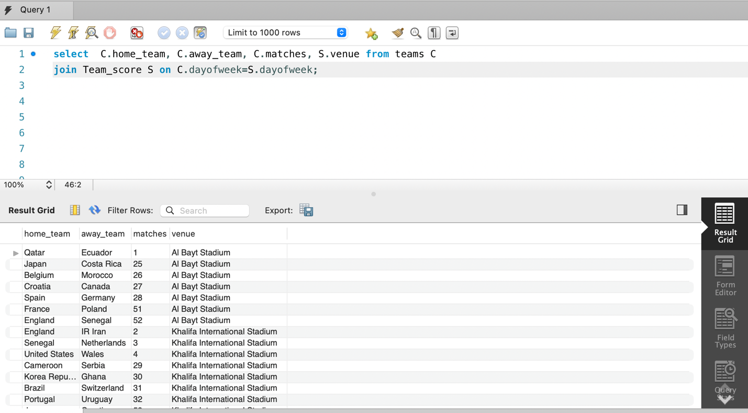

1. To know the score of the match with team names.

select C.home_team, C.away_team, C.matches, S.score from teams C join Team_score S on C.dayofweek=S.dayofweek;

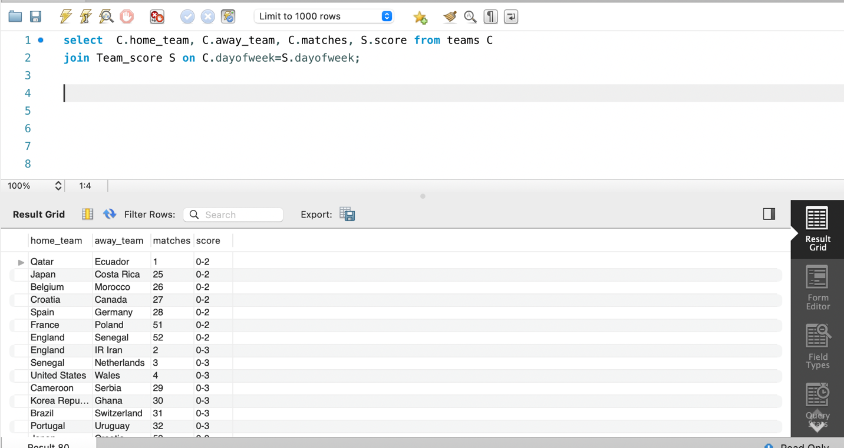

1. To know the matches who won with score and total shots.

Select C.away_team, C.matches, C.home_aerials_won, C.away_aerials_won, S.score, S.home_total_shots, S.away_total_shots

from matches_won C join total_shots S on C.home_team=S.home_team.

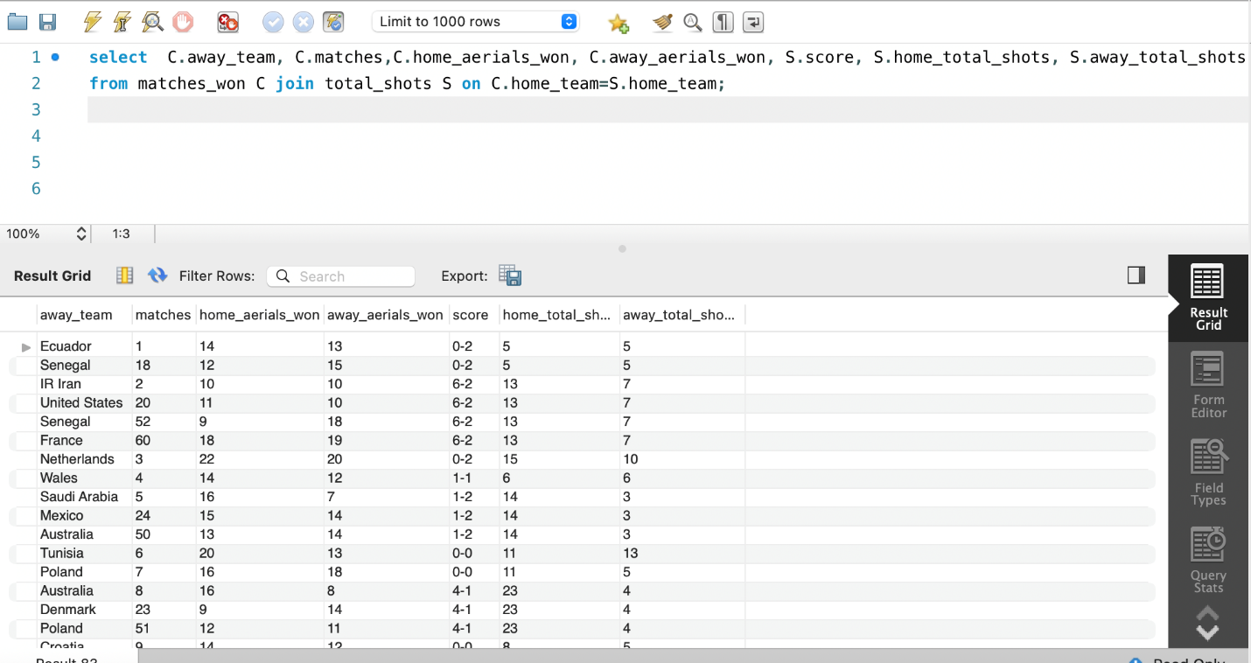

1. To know the number of people attended the match and the team possession.

select C.home_team, C.away_team, C.attendance, S.home_possession, S.away_possession

from audience_attendance C join team_possession S on C.matches=S.matches;

